GENERAL HEAD-TO-TOE ASSESSMENT EVALUATION
Note: Every patient will require additional specific focused assessments based on condition(s).

- Hand hygiene before you begin.
- Introduce yourself & check ID band for 2 identifiers to confirm “right patient”
- Deal with any immediate problems (chest pain, bleeding, etc., if present)

Use your stethoscope to…
- Listen to heart sounds under gown/clothing
  - Since heart valves make the heart sounds, listen over all 4 valves: A.P.T.M. (aortic, pulmonic, tricuspid, mitral)
  - Tell patient that you will listen for apical pulse for full minute over mitral valve. Record BOTH rate & rhythm of AP (ex.: 65 regular or 104 irregular)
- Listen to bowel sounds in all 4 quadrants under gown/clothing
  - Use umbilicus as landmark so listening in quadrants correctly.
- Listen to lung sounds (both ANTERIOR and POSTERIOR) under gown/clothing
  - Have patient roll on side if unable to sit forward.
  - Tell patient to take deep breaths through mouth.
  - Listen to one complete inspiration & expiration cycle before moving stethoscope.

- Check radial pulses and arm
  - Look at IV sites while you're there.
- Check pedal pulses and legs
  - Check cap refill when you lift up your fingers from checking pedal pulse
- Check perineal area, if patient has foley or applicable condition.
- Check ALL equipment (anything attached - or that should be attached - to pt)
  - Nasal cannula or other supplemental oxygen device
  - IV pump & fluids  chest tube  onQ pump  JP drain  SCDs or TEDs

Finish up with all of your questions:
- Pain? If yes, get full WILDAA:
  - Words (ex., ache, pressure, stabbing, dull, radiating, etc.)
  - Intensity (0-10 scale)
  - Location (Where is pain? May be in more than one place)
  - Duration (When did it start? Is it continuous or intermittent?)
  - Aggravating & Alleviating Factors (What makes it better, what makes it worse?)
- Nausea or Vomiting?
- Numbness or Tingling?
- Last BM?
- Check orientation with the “3 silly questions.”
What is…  name of this place?  month & year?  your full name?
- What is the patient’s goal for the shift?

- Hand hygiene as you leave.
developed by Raney Linck, RN
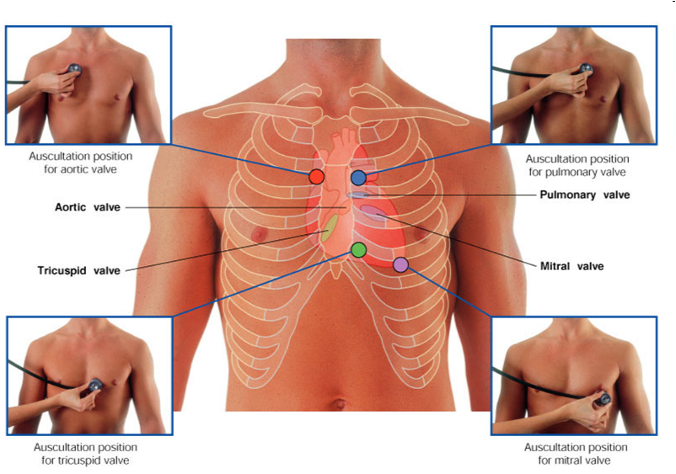
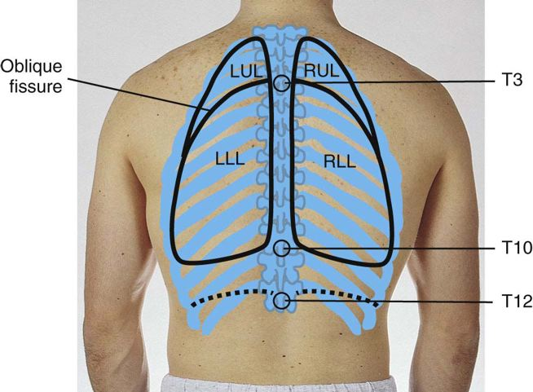
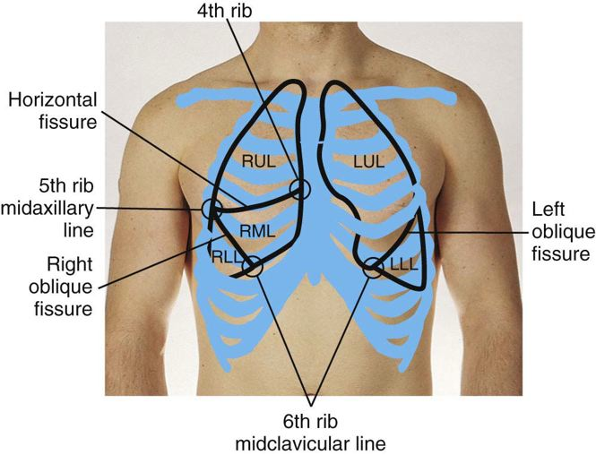
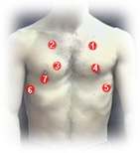
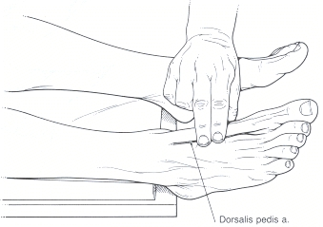
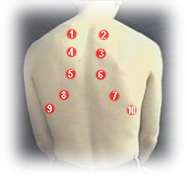
1.
2.
3.
4.

1. Drake, R., Vogl, A.W., & Mitchell, A.W. (2010). Gray's anatomy for students (2nd ed.). Philadelphia, PA: Churchill Livingstone Elsevier.
2. Jarvis, C. (2012). Physical examination and health assessment (6th ed.). St. Louis, MO: Elsevier.
3. Medical Doctor Apps. (2013). Heart and lung sounds: Medical reference tool (Version 2.0) [Mobile application software]. Retrieved from http://itunes.apple.com
4. Walker, H.K., Hall, W.D., & Hurst, J.W. (1990). Clinical methods: The history, physical, and laboratory examinations (3rd ed.). Boston: Butterworths. Retrieved from http://www.ncbi.nlm.nih.gov/books/NBK201/

